CARIAD SE CPM Project
Functional Specification

Jira Interface

Person Responsible: | Jimmy Xu
Status: | in review
Version: | V1.0
Date: | 22/10/2025

Version History:
Version | Date | Author | Comments
V1.0 | 22/10/2025 | Jimmy Xu

Business Purpose
As described in “Fine Estimation” process, by starting EFES task in Jira, EFES task master data will be created automatically in SAP. SAP EFES Task status will be updated afterwards.
Planning status and figures in SAP will be synchronized to Jira to give an overview in Jira.
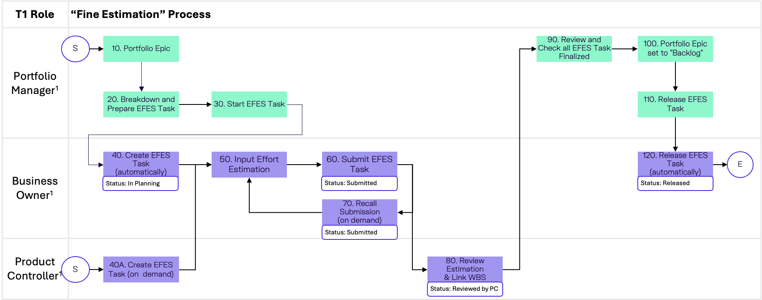

Functional Specification

Technic Prerequisite
Create customized table in SAP.
Field | Key | Data Type
Task ID | Yes | CHAR, 40
Task Name |  | CHAR, 80
Type |  | CHAR, 40
Jira Status |  | CHAR, 40
Task Status |  | CHAR, 40
Priority |  | CHAR, 40
Start Date |  | DATS, 8
End Date |  | DATS, 8
Assignee |  | CHAR, 40
Reporter |  | CHAR, 40
Description
Labels |  | CHAR, 80
Jira2SAP Timestamp
SAP2Jira Timestamp
Last Update Timestamp

Interface: Jira to SAP

Data Structure
Read delta tickets with following fields from Jira and transport to SAP.
Field | Key | Comment
Task ID | Yes | Only get newly created or updated tickets from last transport.
Summary
Type |  | Set filter: Sub-task
Jira Status
Priority
Start Date
End Date
Assignee
Reporter
Description
Labels

Inbound Data Handling
Update entries by Task IDs in customized table by mapping following:
Jira Field | SAP Field | Comment
Task ID | Task ID | Directly mapping
Summary | Task Name | Directly mapping
Type | Type | Directly mapping
Jira Status | Jira Status | Directly mapping
Priority | Priority | Directly mapping
Start Date | Start Date | Directly mapping
End Date | End Date | Directly mapping
Assignee | Assignee | Directly mapping
Reporter | Reporter | Directly mapping
Description | Description | Directly mapping
Labels | Labels | Directly mapping
 | Jira2SAP Timestamp | Current Time

Interface: SAP to Jira

Outbound Data Handling
Read delta entries with following fields and transport to Jira.
Field | Key | Comment
Task ID | Yes | Only get entries which Last Update Timestamp > SAP2Jira Timestamp.
Task Status

Data Structure
Update Jira tickets by Task IDs mapping following:
SAP Field | Jira Field | Comment
Task ID | Task ID | Directly mapping
Task Status | Comment | Create a new comment

Result Handling
If Jira tickets are successfully updated, update customized table as following.
Field | Comment
Task ID
SAP2Jira | Current Time

Authorization
NA

Others

